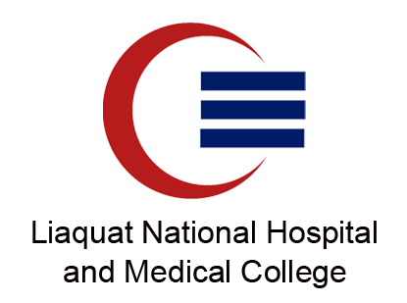
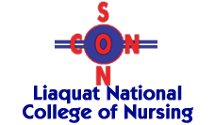
Department of Health Professions Education and
Liaquat National College of Nursing

BASICS OF EFFECTIVE TEACHING SKILLS
FOR NURSING EDUCATORS

21-22 November 2022

Registration Form

Instruction: Please fill the form completely.

Full Name (BLOCK LETTER): _________________________________________________

Gender: Male Female

Qualification: ____________________________________________________________

Currently employed: Yes No

If yes, what is your present designation? ______________________________________

Name of Institution where employed: ______________________________________

Year/s of Experience of teaching (if any): _____________________________________

Contact Number: _________________________________________________________

Email address: ___________________________________________________________

_____________ Date:_________
Signature

Note:
- Pay fee at LNH Cash counter, Block “C”, Next to Wajid Ali Shah Complex
- Submit registration form along with copy of paid voucher at Department of Health Professions Education, Block M, Near Convention Centre, LNH

